Poisson Distribution:

Definition: In probability theory and statistics, the Poisson distribution is a discrete probability distribution that expresses the probability of a given number of events occurring in a fixed interval of time if these events occur with a known constant mean rate and independently of time since the last event.

Probability mass function is used.

Describes the number of events occurring in fixed time intervals.

Example: No. of people visiting train station every hour.

Example: No. of people visiting bank every hour.

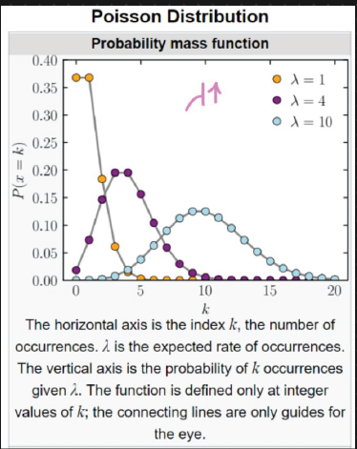

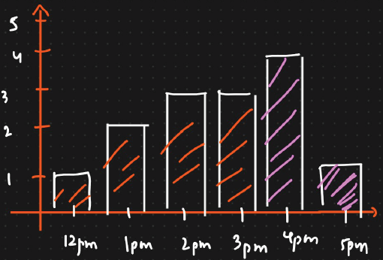

λ = 3 = Expected no. of events occurring at a time at every time interval

PMF:

Q: What is the probability of a person visiting the 5th hour?

P(X) = $\frac{e^{-λ}λ^{x}}{x!}$

Considering λ = 3

P(X=5) = $\frac{e^{-3}3^{5}}{5!}$ = 0.1

Q: What is the probability of a person visiting the 4th and 5th hour?

P(X) = $\frac{e^{-λ}λ^{x}}{x!}$

Considering λ = 3

P(X=4) + P(X=5) = $\frac{e^{-3}3^{5}}{5!}$ + $\frac{e^{-3}3^{4}}{4!}$ = 0.1008 + 0.1681 = **0.2689**

Q: What is the probability of a person visiting in or before 3rd hour?

P(X) = $\frac{e^{-λ}λ^{x}}{x!}$

Considering λ = 3

P(X=12) + P(X=1) + P(X=2) + P(X=3) = = $\frac{e^{-3}3^{12}}{12!}$ + $\frac{e^{-3}3^{1}}{1!}+ \frac{e^{-3}3^{2}}{2!} + \frac{e^{-3}3^{3}}{3!}$ = **0.0498**

Mean of Poisson Distribution:

Mean = E(x) = μ = λ * t = Variance

λ = Expected number of events occurring at every time interval

t = Time interval